**Create Windows Server 2016 Virtual Machine**

**Step 1:** Open Azure Portal and enter credentials

<https://portal.azure.com>

**Step 2:** Click on **+New -> Compute -> Windows Server 2016 Datacenter**

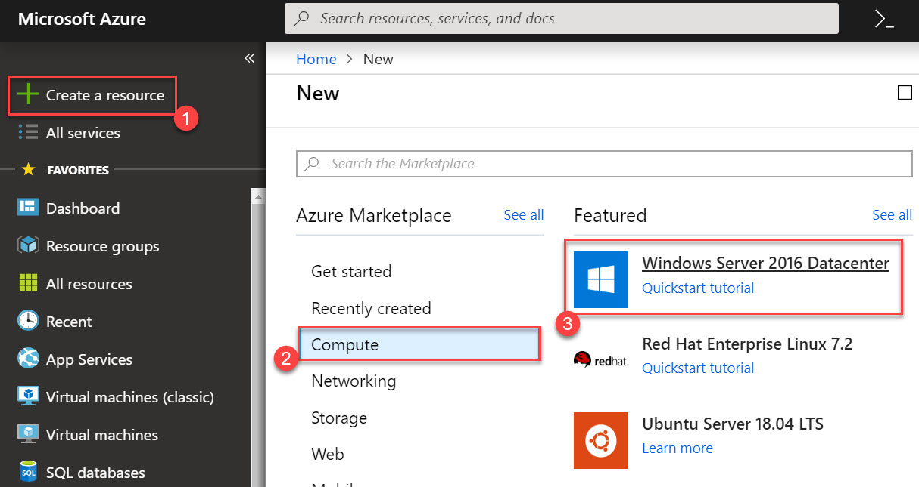

**Step 3:** Enter Virtual Machine Basics details

**Subscription:** Choose your Subscription

**Resource Group:** Create New -> **WinVMRG**

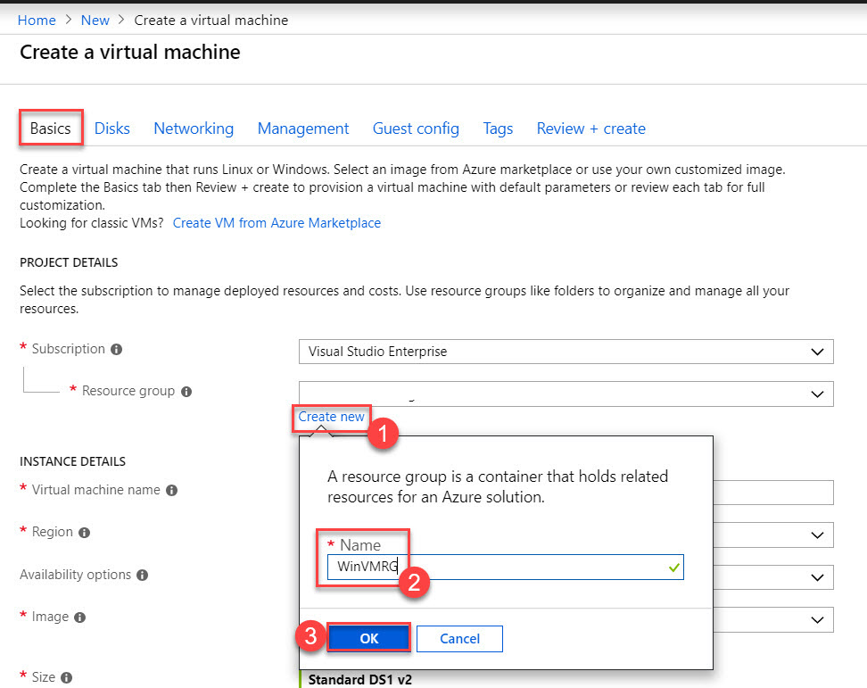

**Virtual Machine Name:** WindowsServerVM

**Region:** Choose any nearest region

**Image:** Windows Server 2016 Datacenter

**Size:** continue with default size or select any other size

**Administrator Username:** demouser

**Administrator Password:** Demouser@123

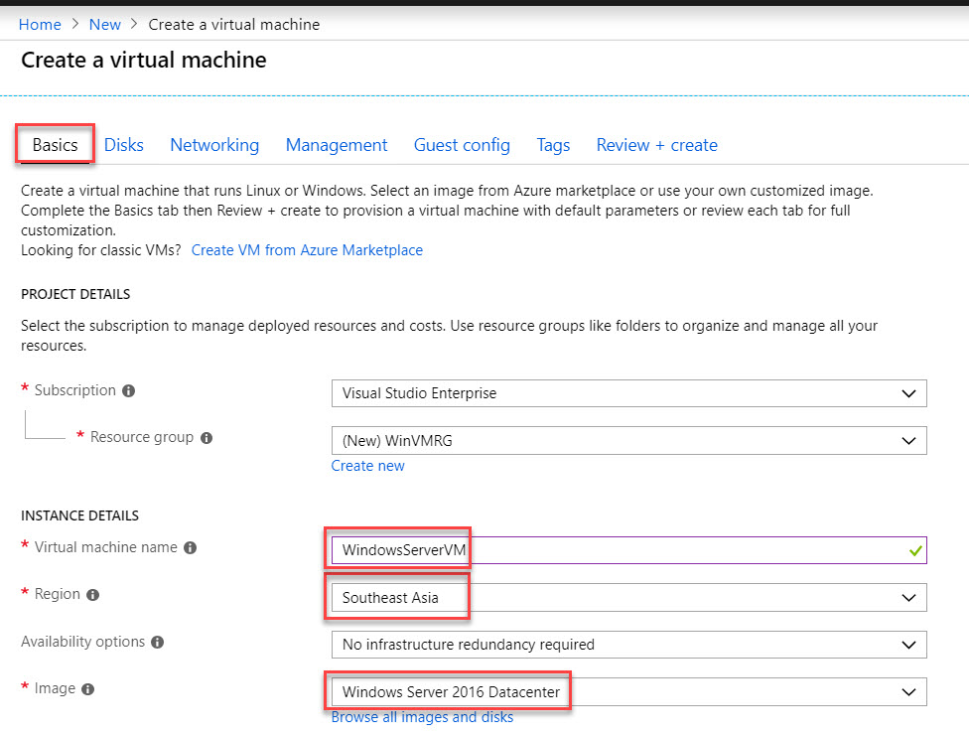

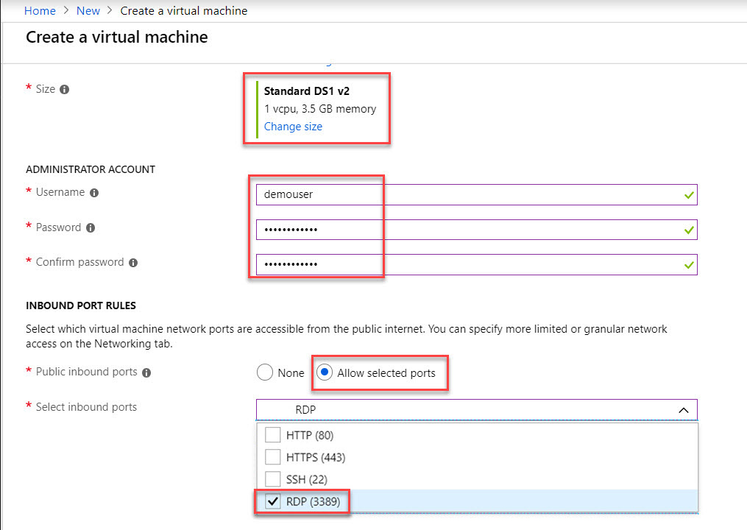

**Public inbound ports:** Allow selected ports. **Select RDP (3389)**

**Windows License:** No

Click on **Next: Disks >** button



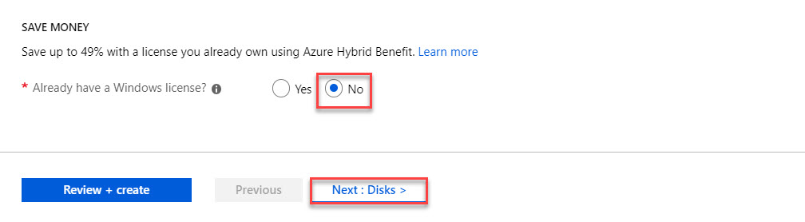

**Step 4:** **Disks** tab

**OS disk type:** Standard HDD

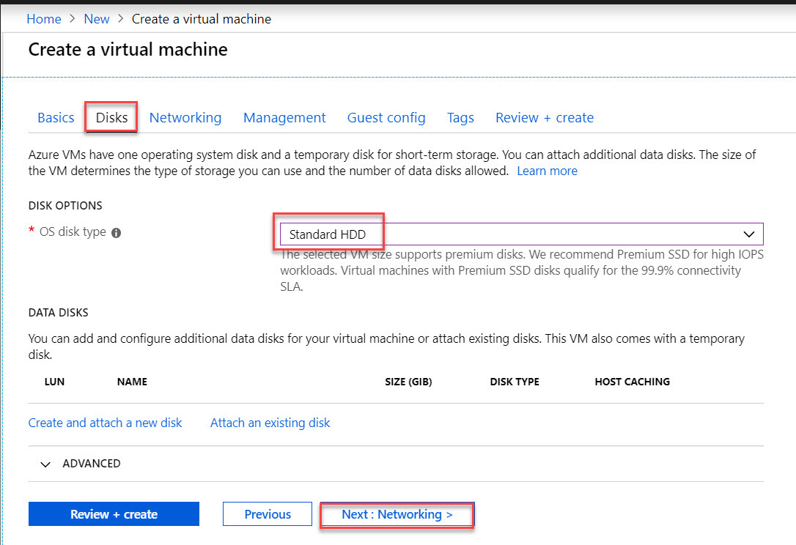

**Step 5: Networking** tab

Continue with default settings

**Virtual network:** Create New

**Subnet:** new

**Public IP:** new

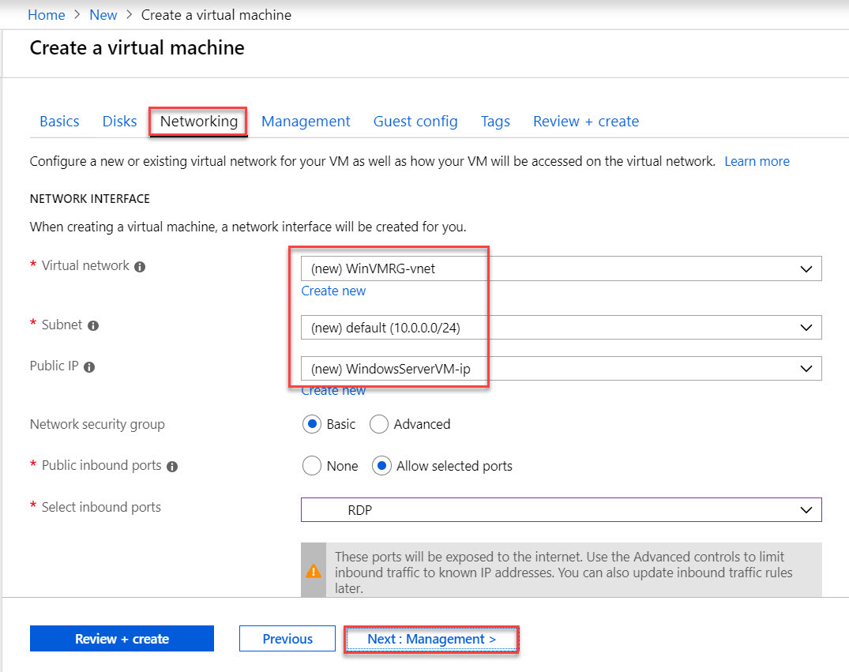

**Step 6:** **Management** tab

Continue with default settings

Click on **Next: Guest config >** button

**Boot diagnostics:** On

**OS guest diagnostics:** Off

**Diagnostics storage account:** new storage account

**Identity:** Off

**Auto-Shutdown:** Off

**Backup:** Off

*Note: for this demo don’t require to setup all.*

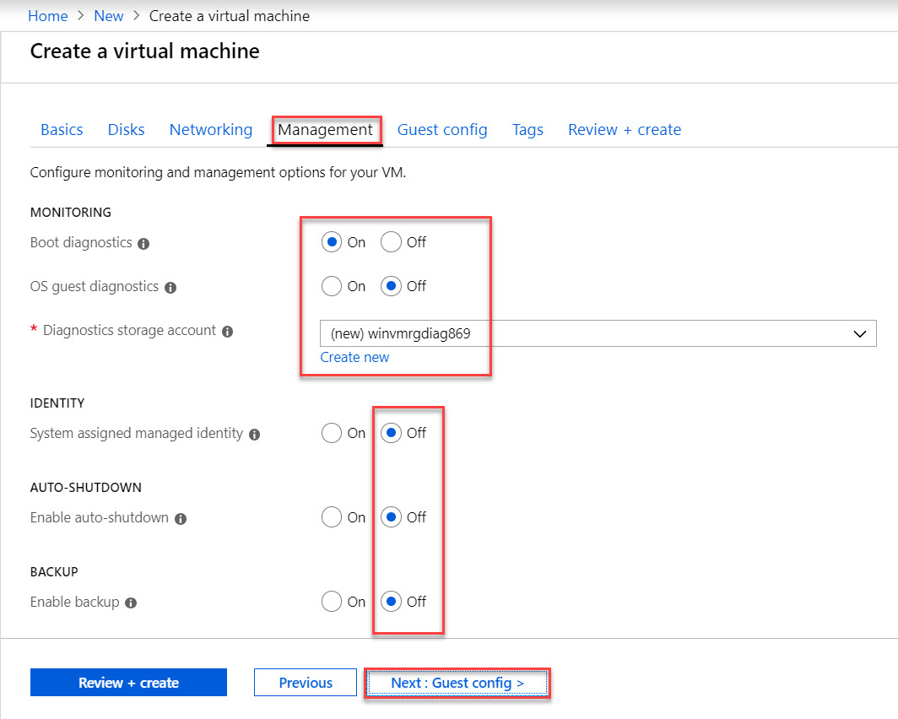

**Step 7:** **Guest config** tab

Click on **Next: Tags >** button

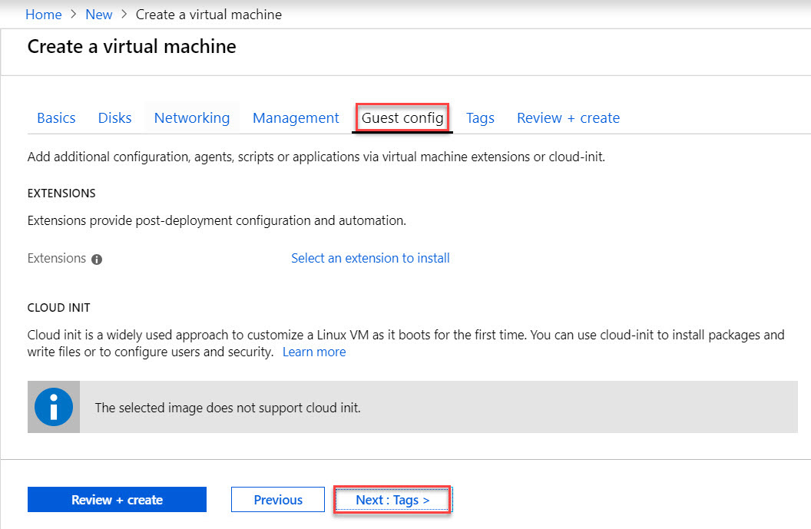

**Step 8:** **Tags** tab.

Click on **Next: Review + create >** button

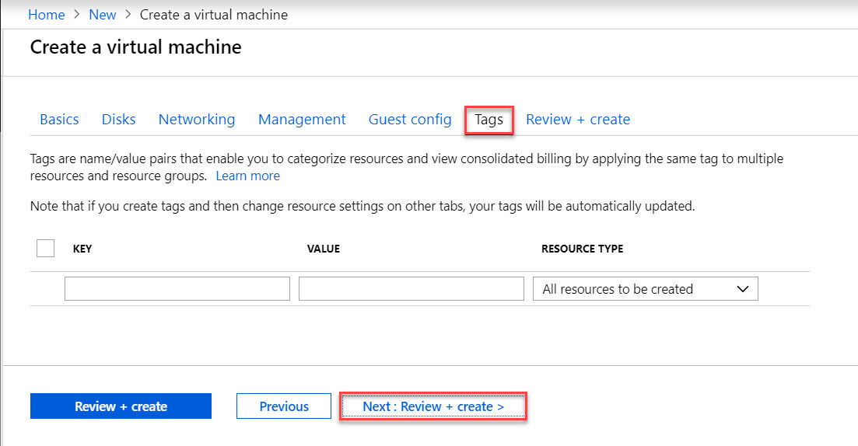

**Step 9:** **Review + create** tab

Validation passed means all settings are right and create virtual machine. If validation failed so verify all the settings.

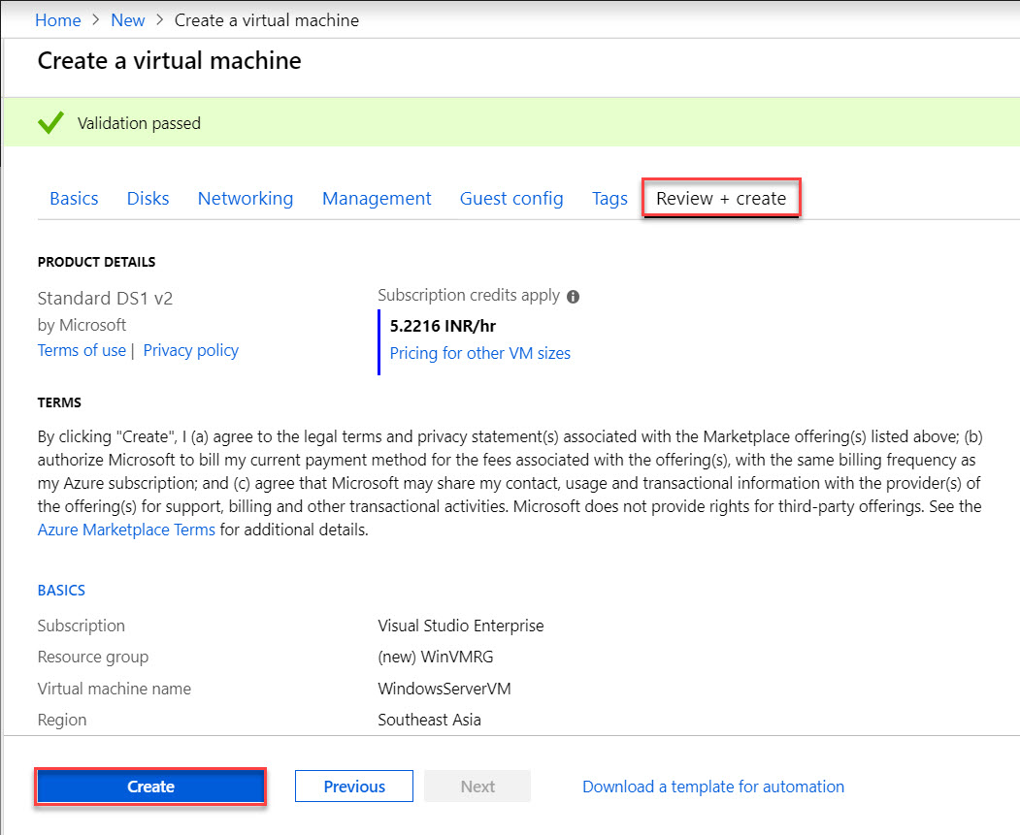

Virtual Machine deployment is underway. Wait for few minutes to complete

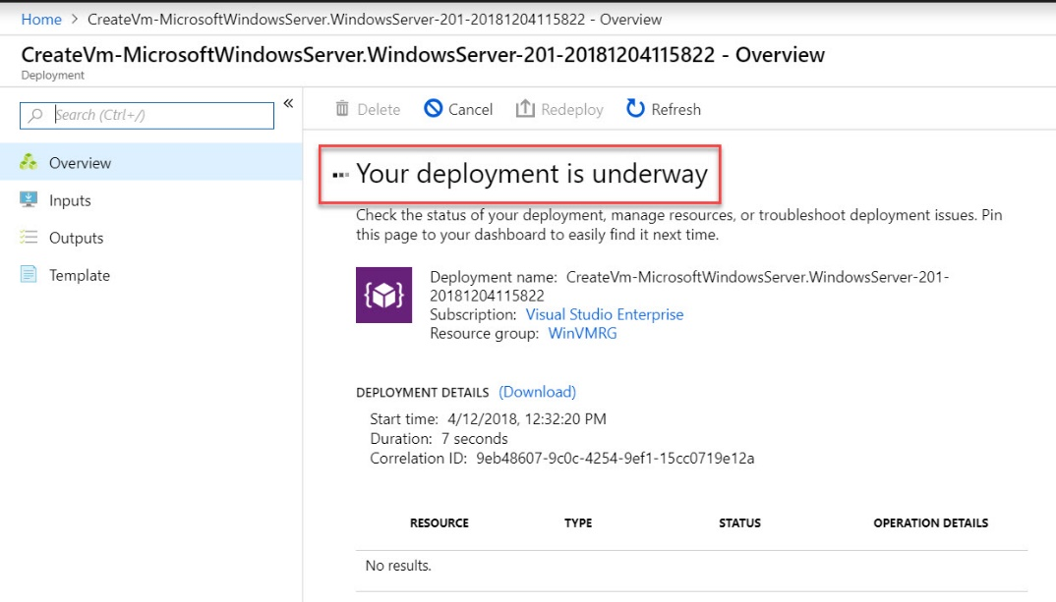

When deployment complete so click on **Go to resource**

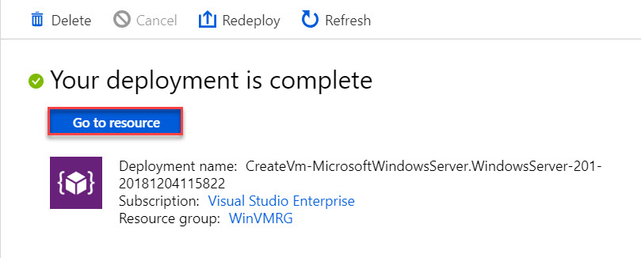

**Step 10:** Click on “**Connect**” button to download RDP file

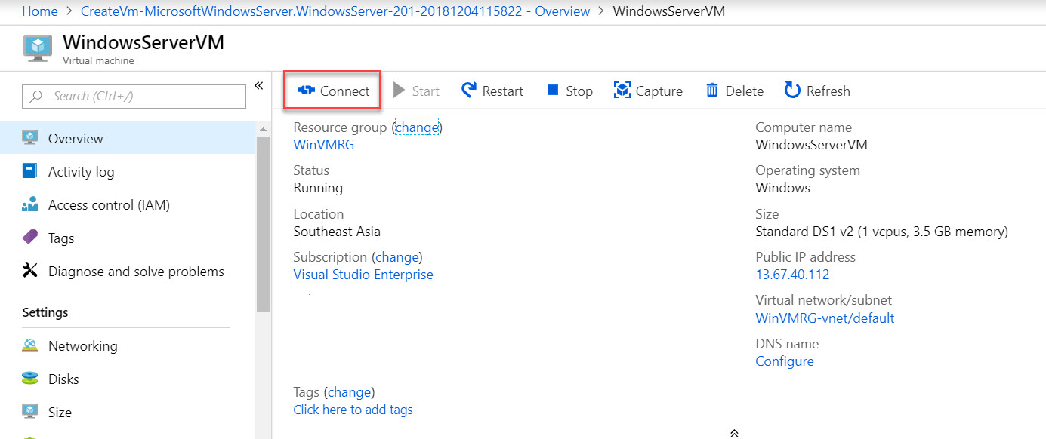

Click on **Download RDP File**

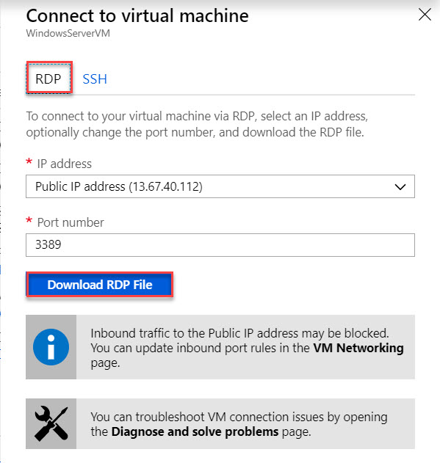

**Step 11:** Double click on RDP file



Remote Desktop Connection wizard will open & again click on “**Connect**” button

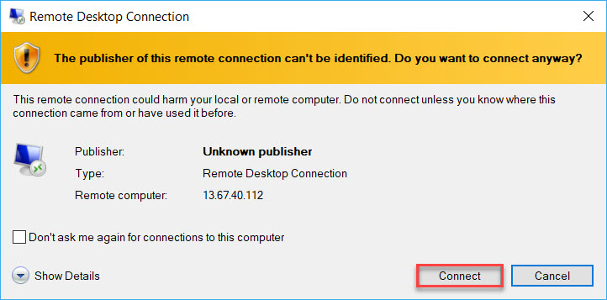

Enter Virtual Machine

**Username: demouser**

**Password: Demouser@123**

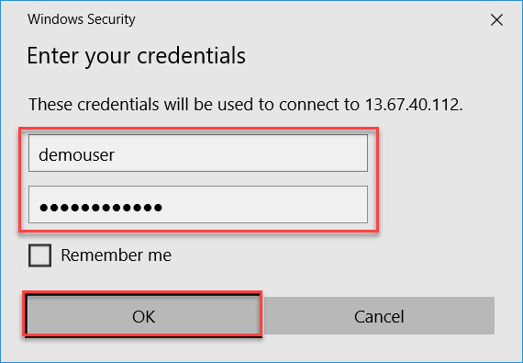

Click on “**Yes**” button to start remote connection

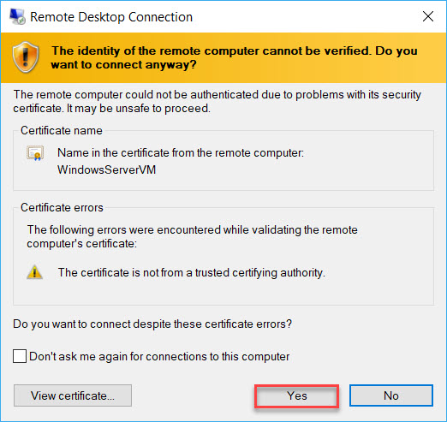

Wait for few seconds to start Windows Server 2016 Datacenter

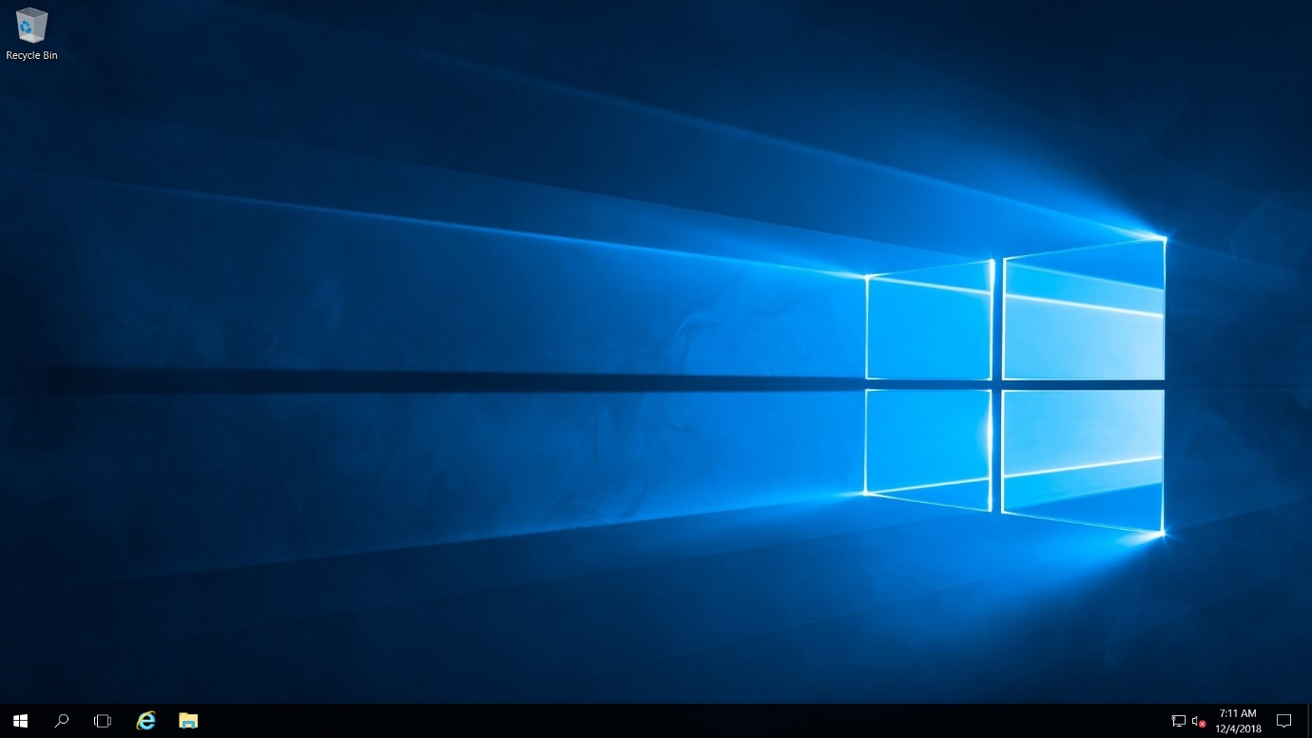

**Step 12:** Click on “**No**” button regarding Network option.

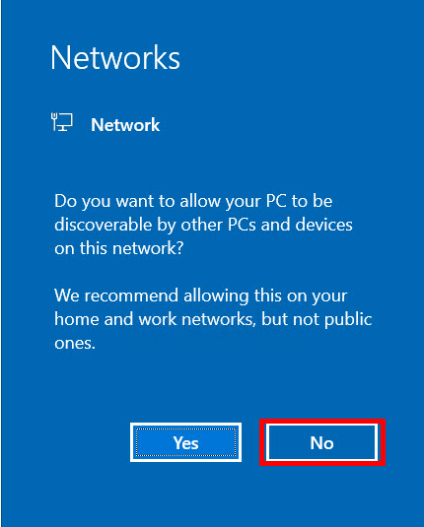

**Step 13:** Automatic Server Manager will start. **Turn** **off IE Enhanced Security configuration**

**Local Server -> IE Enhanced Security Configuration**

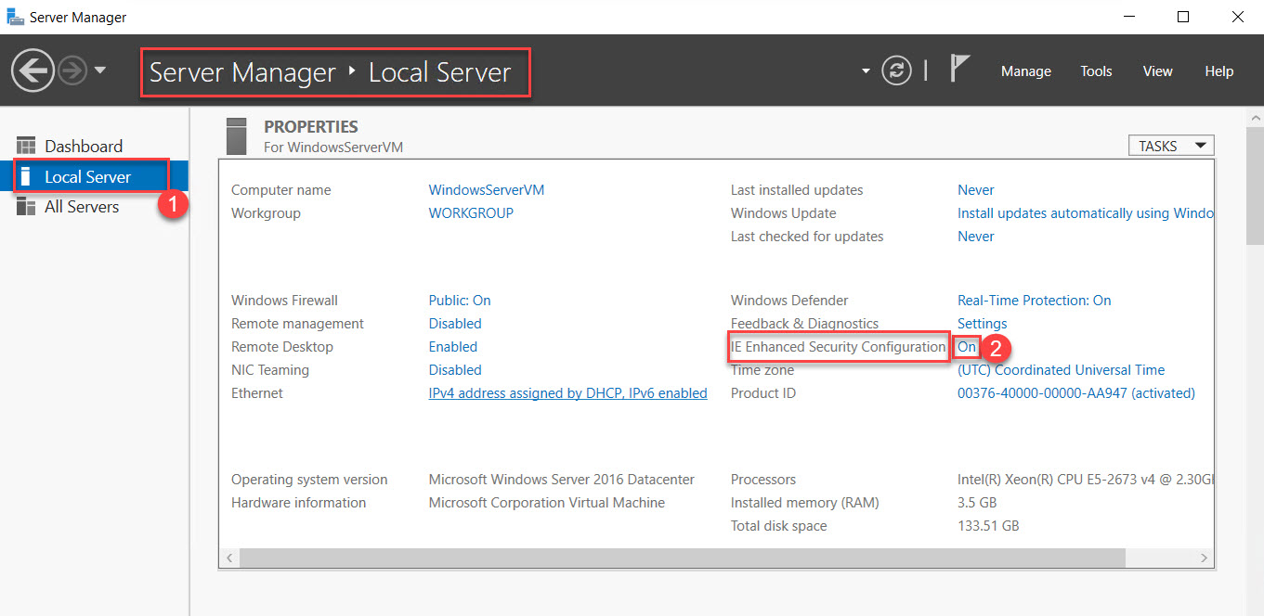

Choose “**Off**” option of Administrators & Users.

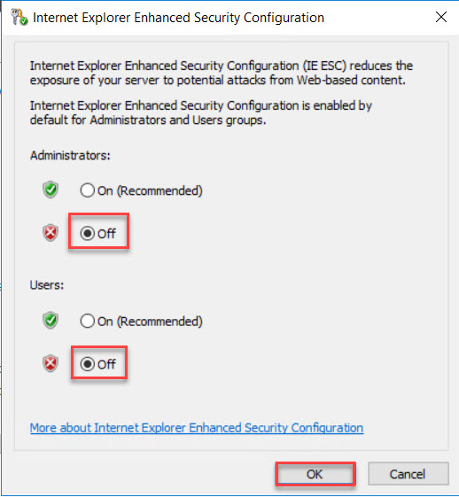

Click on **close** button of Server Manager.

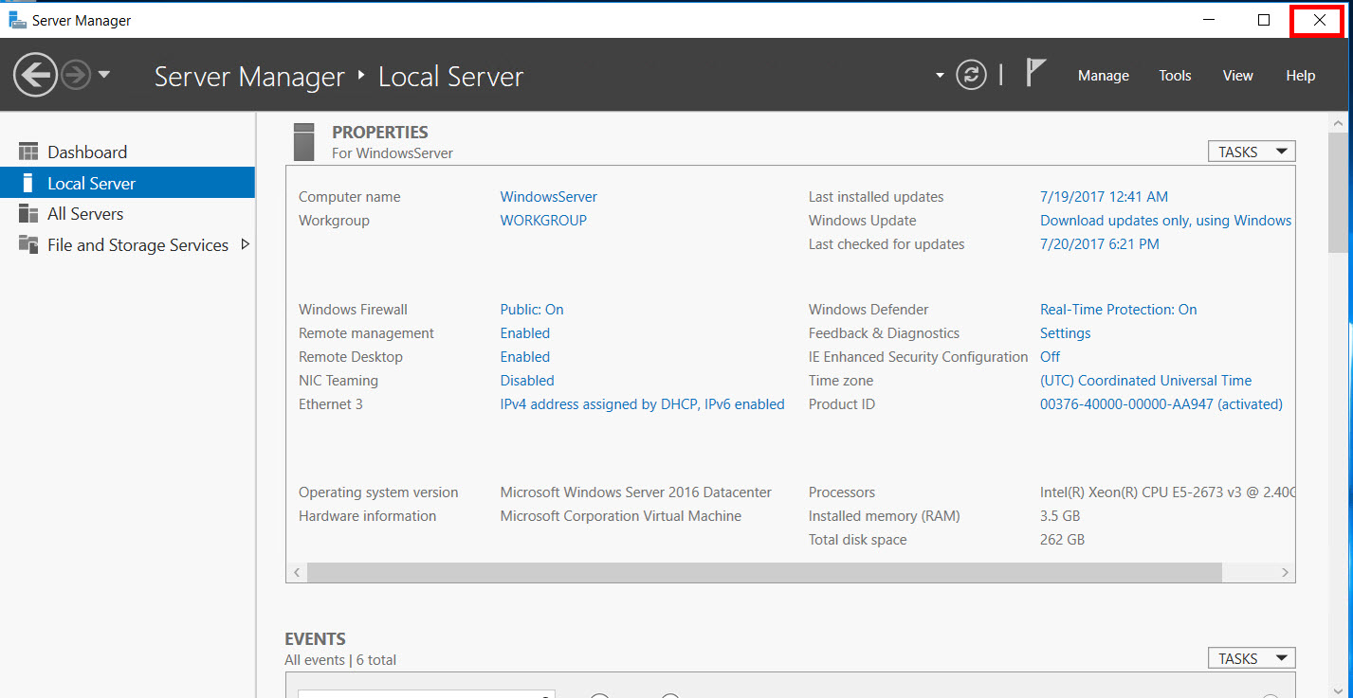

**To Configure IIS on Windows Server 2016 there are two methods available:**

1. Using Server Manager Wizard
2. Using PowerShell Command

**Method 1: Using Server Manager Wizard**

**Step 14:**

**Method 2: Using PowerShell Command**

**Step 14:** Click on **Start Menu -> Right click on “Windows PowerShell” -> More -> Run as administrator**

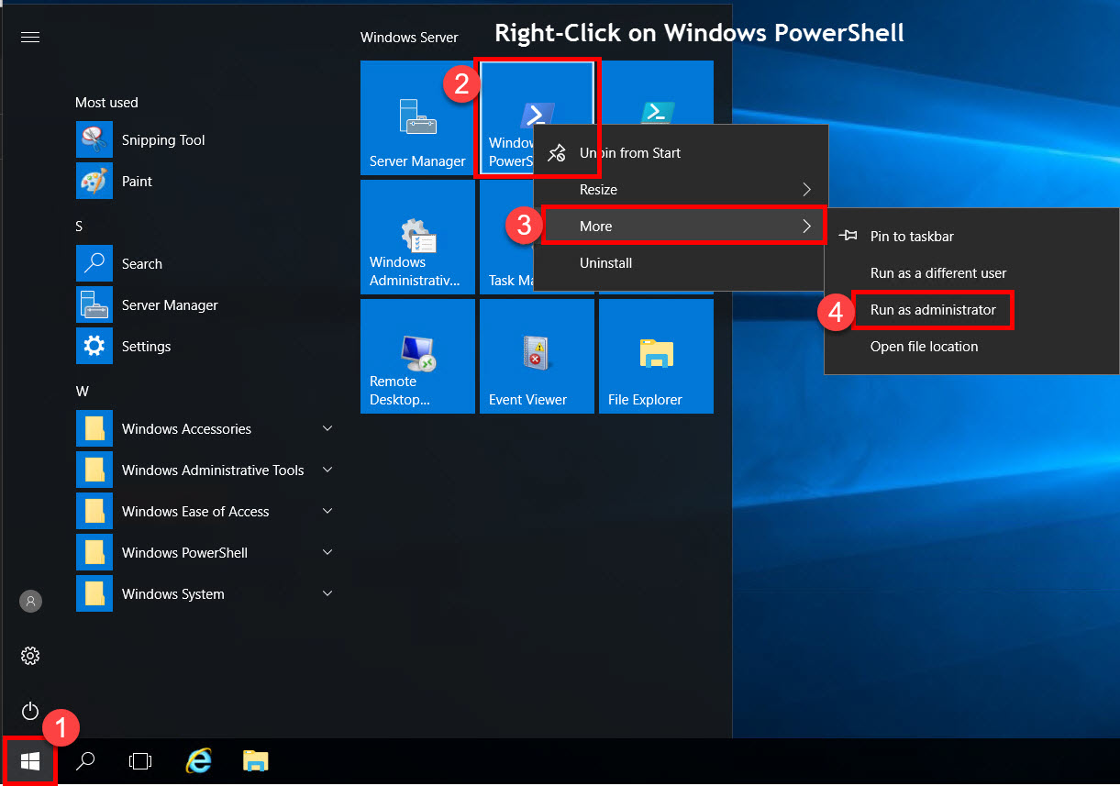

**Step 15:** Windows PowerShell will start.

Type below command:

***Install-WindowsFeature -name Web-Server -IncludeManagementTools***

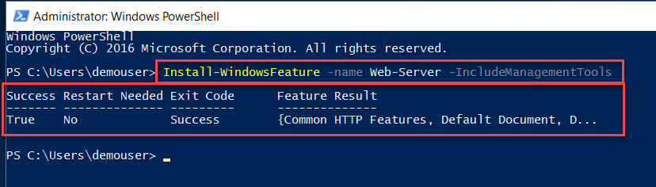

Note: it will take few minutes to install Web Server Feature.

**Step 16:** Press **Windows + R** button or start **Run**.

Type notepad & hit enter button

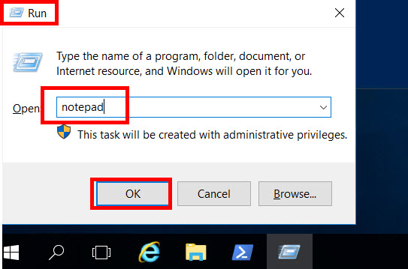

**Step 17:** Create basic HTML page like as below:

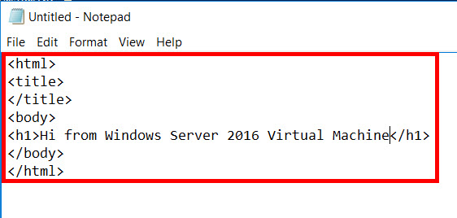

<html>

<title>

</title>

<body>

<h1>Hi from Windows Server 2016 Virtual Machine</h1>

</body>

</html>

**Step 18:** Select **Save** option.

Navigate to **This PC > Local Disk (C:) > inetpub > wwwroot**

**File Name: index.html**

**Save as type: All Files**

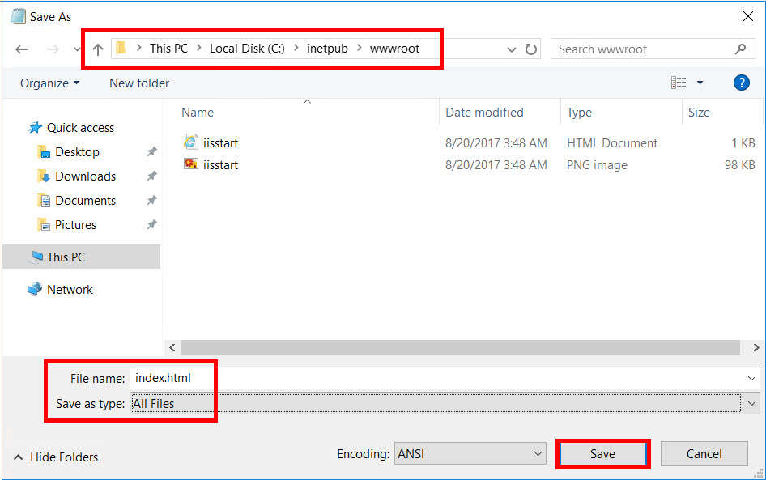

**Step 19:** Now minimize the Virtual Machine & Navigate to Azure Portal.

Click on **Resource Group** (left side) -> “**WinVMRG**”

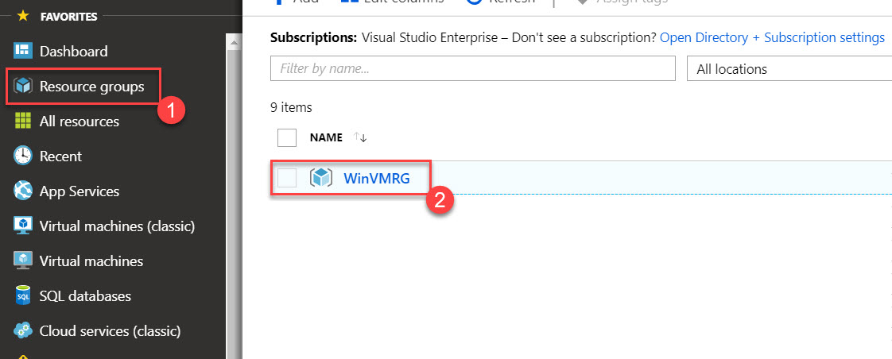

**Step 20:** Resource Group Blade will open & list all the resource under this resource group. Click on **Network Security Group (NSGs)**.

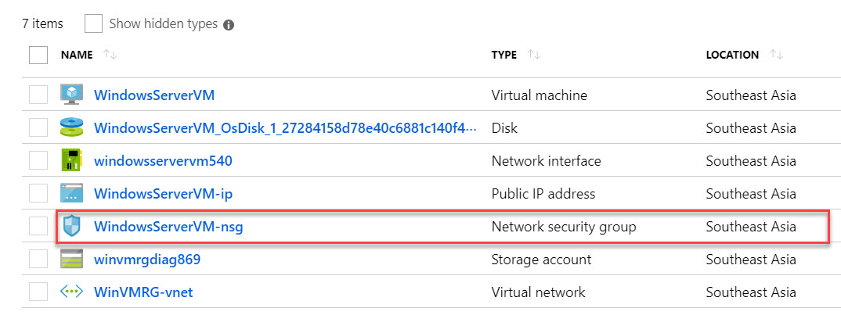

**Step 21:** Select **“Inbound Security rules” -> +Add**

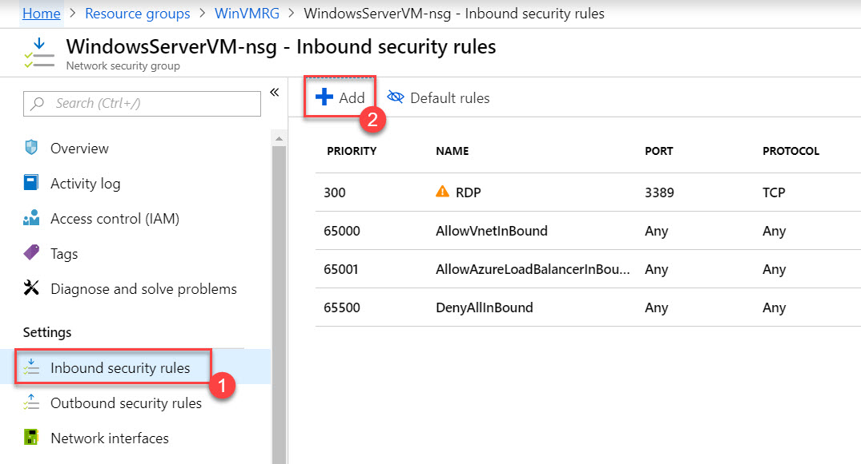

**Step 22:** New inbound security rule blade will open

Click on **Basic** option

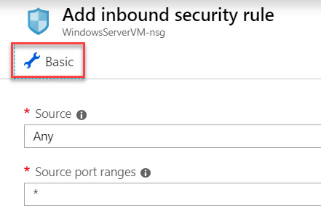

**Service: HTTP**

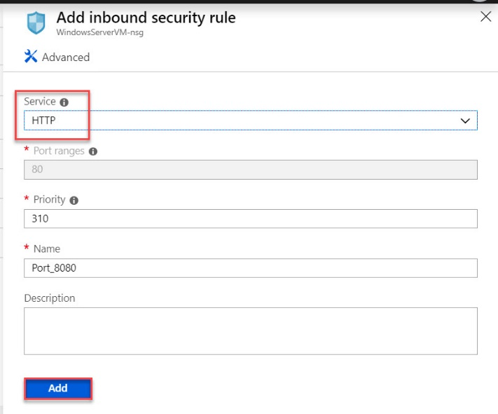

**Step 23:** After adding HTTP rule click on Resource Group once again and select resource group



Select Virtual Machine Ex. WindowsServerVM

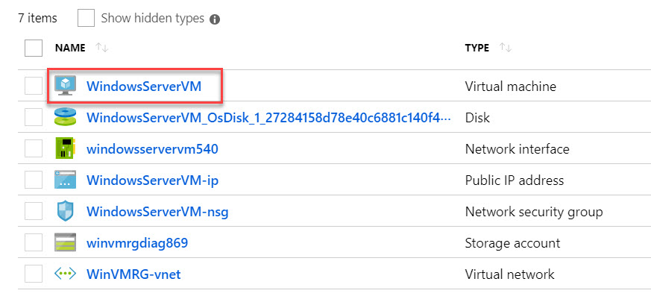

**Step 24:** Copy “**Public IP Address**”

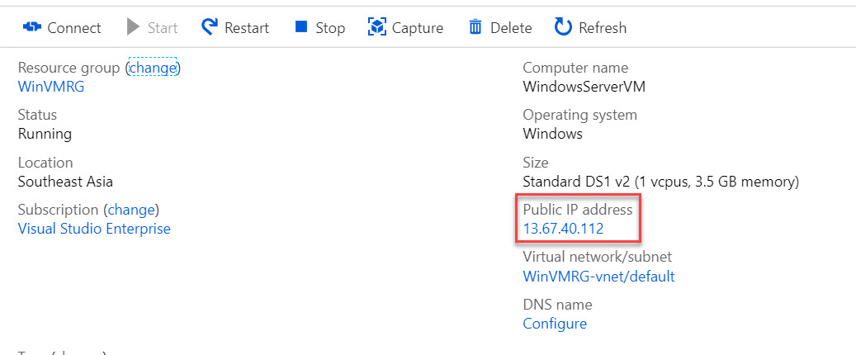

**Step 25:** Open any browser and paste IP address. Website will load

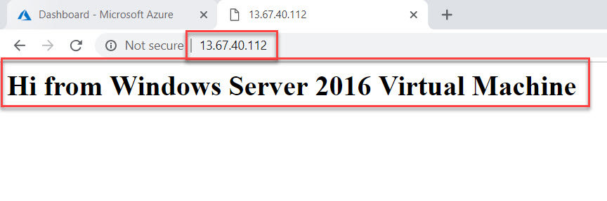

**Delete Virtual Machine**

**Step 26:** Select Resource Group



**Step 27:** Click on **Delete resource group** button

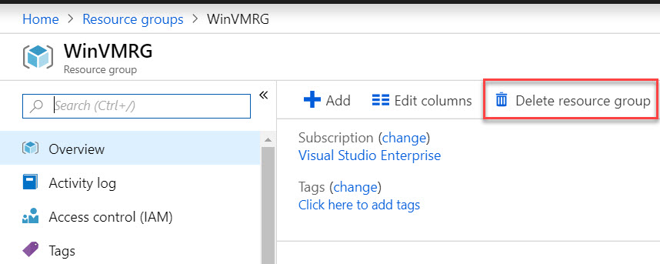

Type Resource Group name and click on Delete button.

